**“2.Spring REST Handson”**

**Hello World RESTful Web Service**   
  
**1.HelloController.java**

package com.cognizant.spring_learn.controller;

import org.slf4j.Logger;

import org.slf4j.LoggerFactory;

import org.springframework.web.bind.annotation.GetMapping;

import org.springframework.web.bind.annotation.RestController;

@RestController

public class HelloController {

private static final Logger *LOGGER* = LoggerFactory.*getLogger*(HelloController.class);

@GetMapping("/hello")

public String sayHello() {

*LOGGER*.info("START");

String message = "Hello World!!";

*LOGGER*.info("END");

return message;

}

}

**2.SpringLearnApplication.java**

package com.cognizant.spring_learn;

import org.slf4j.Logger;

import org.slf4j.LoggerFactory;

import org.springframework.boot.SpringApplication;

import org.springframework.boot.autoconfigure.SpringBootApplication;

@SpringBootApplication

public class SpringLearnApplication {

private static final Logger *LOGGER* = LoggerFactory.*getLogger*(SpringLearnApplication.class);

public static void main(String[] args) {

*LOGGER*.info("STARTING: SpringLearnApplication");

SpringApplication.*run*(SpringLearnApplication.class, args);

*LOGGER*.info("STOPPING: SpringLearnApplication");

}

}

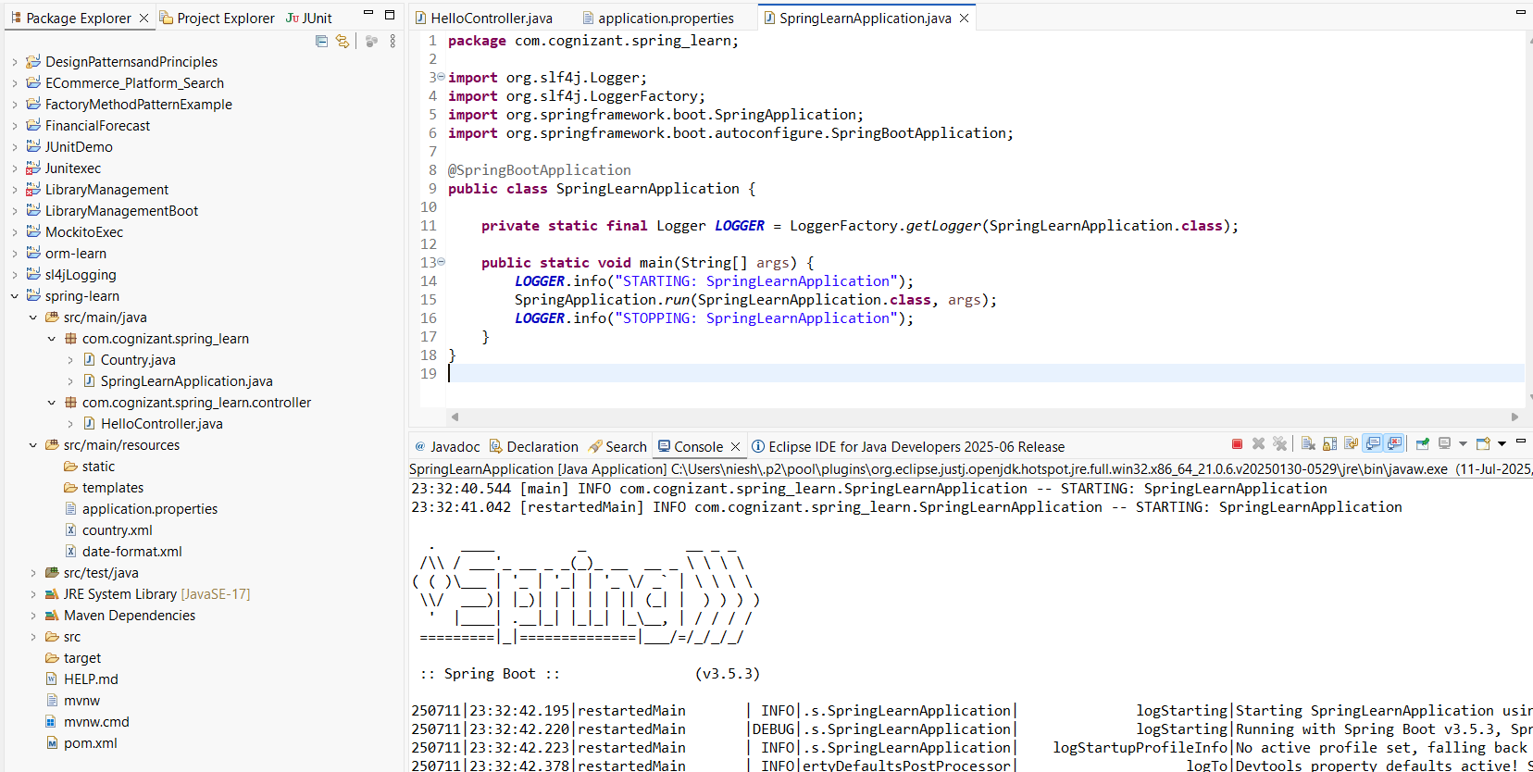

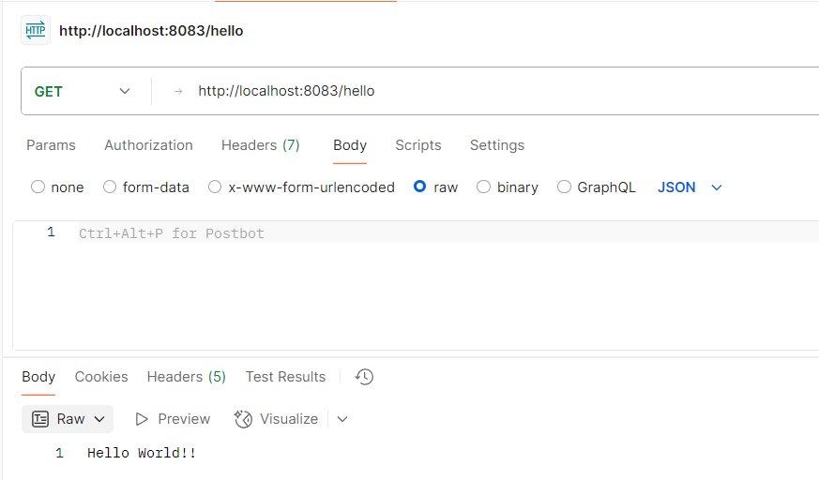

**---------------------------------------------------------------------------------------------------------------------------**

**REST - Country Web Service**

**1.Country.java**

package com.cognizant.spring_learn;

import org.slf4j.Logger;

import org.slf4j.LoggerFactory;

public class Country {

private static final Logger LOGGER = LoggerFactory.getLogger(Country.class);

private String code;

private String name;

public Country() {

LOGGER.debug("Inside Country Constructor.");

}

public String getCode() {

LOGGER.debug("Getting Country Code: {}", code);

return code;

}

public void setCode(String code) {

LOGGER.debug("Setting Country Code: {}", code);

this.code = code;

}

public String getName() {

LOGGER.debug("Getting Country Name: {}", name);

return name;

}

public void setName(String name) {

LOGGER.debug("Setting Country Name: {}", name);

this.name = name;

}

@Override

public String toString() {

return "Country [code=" + code + ", name=" + name + "]";

}

}

**2.CountryController.java**

package com.cognizant.spring_learn.controller;

import com.cognizant.spring_learn.Country;

import org.slf4j.Logger;

import org.slf4j.LoggerFactory;

import org.springframework.context.ApplicationContext;

import org.springframework.context.support.ClassPathXmlApplicationContext;

import org.springframework.web.bind.annotation.RequestMapping;

import org.springframework.web.bind.annotation.RestController;

@RestController

public class CountryController {

private static final Logger *LOGGER* = LoggerFactory.*getLogger*(CountryController.class);

@RequestMapping("/country")

public Country getCountryIndia() {

*LOGGER*.info("START");

ApplicationContext context = new ClassPathXmlApplicationContext("country.xml");

Country country = context.getBean("country", Country.class);

*LOGGER*.debug("Country : {}", country.toString());

*LOGGER*.info("END");

((ClassPathXmlApplicationContext) context).close();

return country;

}

}

**3.SpringLearnApplication.java**

package com.cognizant.spring_learn;

import org.slf4j.Logger;

import org.slf4j.LoggerFactory;

import org.springframework.boot.SpringApplication;

import org.springframework.boot.autoconfigure.SpringBootApplication;

@SpringBootApplication

public class SpringLearnApplication {

private static final Logger LOGGER = LoggerFactory.getLogger(SpringLearnApplication.class);

public static void main(String[] args) {

LOGGER.info("STARTING: SpringLearnApplication");

SpringApplication.run(SpringLearnApplication.class, args);

LOGGER.info("STOPPING: SpringLearnApplication");

}

}

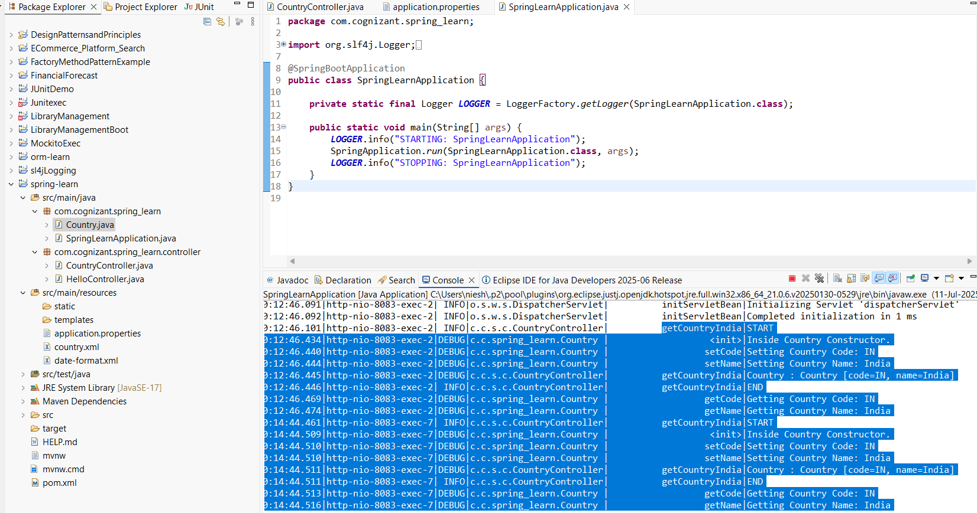

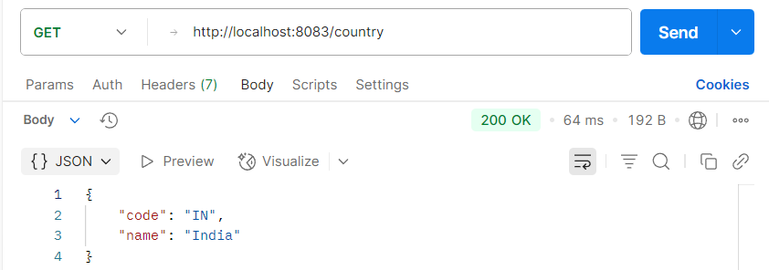

---------------------------------------------------------------------------------------------------------------------------

**REST - Get all countries**

**1.SpringLearnApplication.java**

package com.cognizant.spring_learn;

import org.slf4j.Logger;

import org.slf4j.LoggerFactory;

import org.springframework.boot.SpringApplication;

import org.springframework.boot.autoconfigure.SpringBootApplication;

@SpringBootApplication(scanBasePackages = "com.cognizant.spring_learn")

public class SpringLearnApplication {

private static final Logger *LOGGER* = LoggerFactory.*getLogger*(SpringLearnApplication.class);

public static void main(String[] args) {

*LOGGER*.info("STARTING: SpringLearnApplication");

SpringApplication.*run*(SpringLearnApplication.class, args);

*LOGGER*.info("STOPPING: SpringLearnApplication");

}

}

**2.CountryController.java**

package com.cognizant.spring_learn.controller;

import java.util.List;

import com.cognizant.spring_learn.Country;

import org.slf4j.Logger;

import org.slf4j.LoggerFactory;

import org.springframework.context.ApplicationContext;

import org.springframework.context.support.ClassPathXmlApplicationContext;

import org.springframework.web.bind.annotation.GetMapping;

import org.springframework.web.bind.annotation.RestController;

@RestController

public class CountryController {

private static final Logger *LOGGER* = LoggerFactory.*getLogger*(CountryController.class);

@GetMapping("/countries")

public List<Country> getAllCountries() {

*LOGGER*.info("START");

ApplicationContext context = new ClassPathXmlApplicationContext("country.xml");

List<Country> countries = context.getBean("countryList", List.class);

*LOGGER*.debug("Country List: {}", countries);

*LOGGER*.info("END");

((ClassPathXmlApplicationContext) context).close();

return countries;

}

}

**3.Country.java**

package com.cognizant.spring_learn;

import org.slf4j.Logger;

import org.slf4j.LoggerFactory;

public class Country {

private static final Logger LOGGER = LoggerFactory.getLogger(Country.class);

private String code;

private String name;

public Country() {

LOGGER.debug("Inside Country Constructor.");

}

public String getCode() {

LOGGER.debug("Getting code");

return code;

}

public void setCode(String code) {

LOGGER.debug("Setting code");

this.code = code;

}

public String getName() {

LOGGER.debug("Getting name");

return name;

}

public void setName(String name) {

LOGGER.debug("Setting name");

this.name = name;

}

@Override

public String toString() {

return "Country [code=" + code + ", name=" + name + "]";

}

}

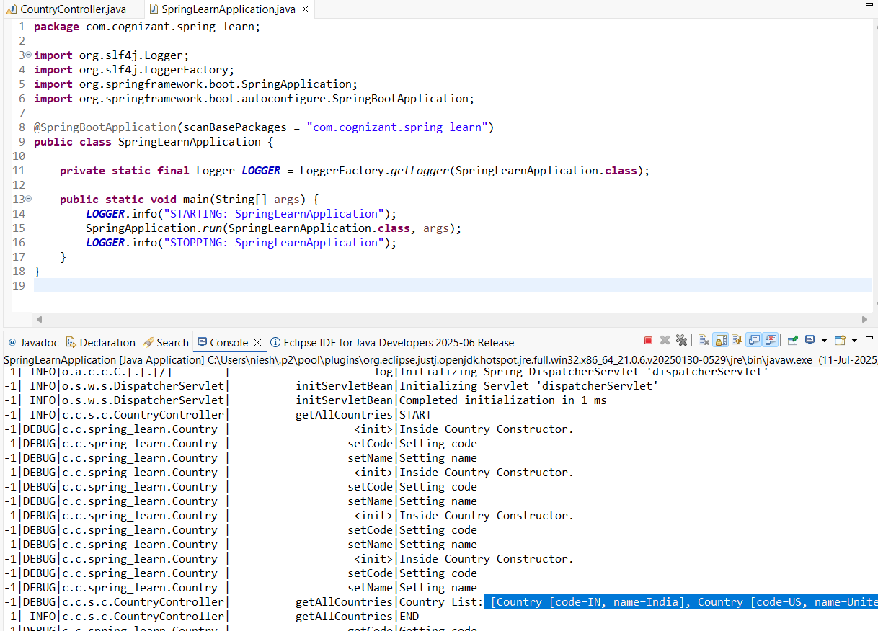

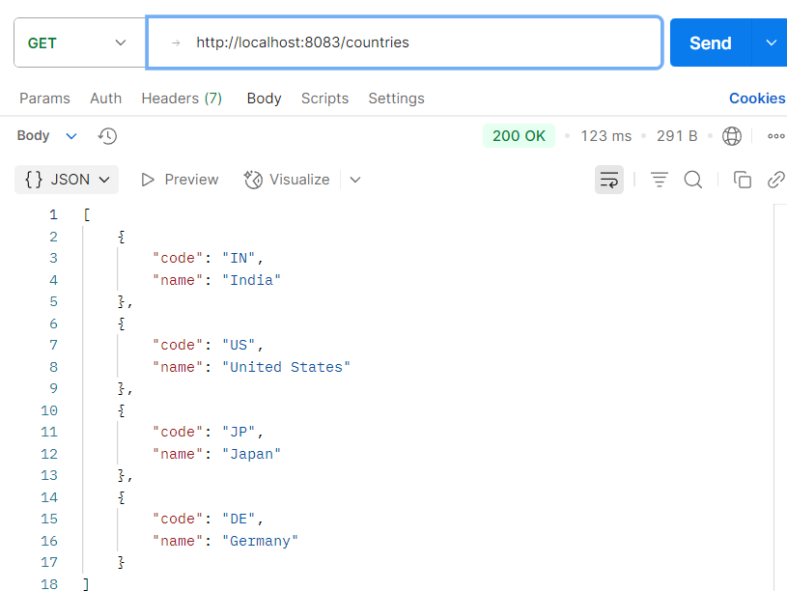

---------------------------------------------------------------------------------------------------------------------------

**REST - Get country based on country code**

**1.Country.java**

package com.cognizant.spring_learn.model;

import org.slf4j.Logger;

import org.slf4j.LoggerFactory;

public class Country {

private static final Logger *LOGGER* = LoggerFactory.*getLogger*(Country.class);

private String code;

private String name;

public Country() {

*LOGGER*.debug("Inside Country Constructor");

}

public String getCode() {

*LOGGER*.debug("getCode called");

return code;

}

public void setCode(String code) {

*LOGGER*.debug("setCode called with {}", code);

this.code = code;

}

public String getName() {

*LOGGER*.debug("getName called");

return name;

}

public void setName(String name) {

*LOGGER*.debug("setName called with {}", name);

this.name = name;

}

@Override

public String toString() {

return "Country [code=" + code + ", name=" + name + "]";

}

}

**2.CountryService.java**

package com.cognizant.spring_learn.service;

import com.cognizant.spring_learn.model.Country;

import org.slf4j.Logger;

import org.slf4j.LoggerFactory;

import org.springframework.context.ApplicationContext;

import org.springframework.context.support.ClassPathXmlApplicationContext;

import org.springframework.stereotype.Service;

import java.util.List;

@Service

public class CountryService {

private static final Logger *LOGGER* = LoggerFactory.*getLogger*(CountryService.class);

public Country getCountry(String code) {

*LOGGER*.info("START - getCountry Service: {}", code);

ApplicationContext context = new ClassPathXmlApplicationContext("country.xml");

List<Country> countryList = context.getBean("countryList", List.class);

Country country = countryList.stream()

.filter(c -> c.getCode().equalsIgnoreCase(code))

.findFirst()

.orElse(null);

((ClassPathXmlApplicationContext) context).close();

*LOGGER*.info("END - getCountry Service");

return country;

}

}

**3.CountryController.java**

package com.cognizant.spring_learn.controller;

import com.cognizant.spring_learn.model.Country;

import com.cognizant.spring_learn.service.CountryService;

import org.slf4j.Logger;

import org.slf4j.LoggerFactory;

import org.springframework.beans.factory.annotation.Autowired;

import org.springframework.web.bind.annotation.*;

@RestController

public class CountryController {

private static final Logger *LOGGER* = LoggerFactory.*getLogger*(CountryController.class);

@Autowired

private CountryService countryService;

@GetMapping("/countries/{code}")

public Country getCountry(@PathVariable String code) {

*LOGGER*.info("START - getCountry: {}", code);

Country country = countryService.getCountry(code);

*LOGGER*.info("END - getCountry");

return country;

}

}

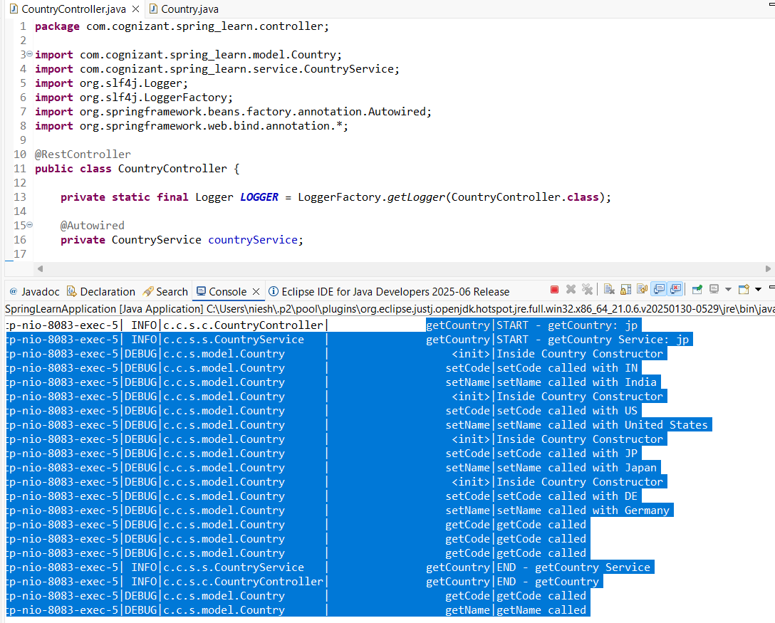

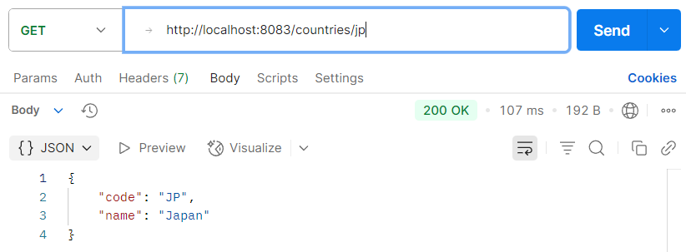

---------------------------------------------------------------------------------------------------------------------------

**REST - Get country exceptional scenario**

**1.Country.java**

package com.cognizant.spring_learn.model;

import org.slf4j.Logger;

import org.slf4j.LoggerFactory;

public class Country {

private static final Logger *LOGGER* = LoggerFactory.*getLogger*(Country.class);

private String code;

private String name;

public Country() {

*LOGGER*.debug("Inside Country Constructor");

}

public String getCode() {

*LOGGER*.debug("getCode called");

return code;

}

public void setCode(String code) {

*LOGGER*.debug("setCode called with {}", code);

this.code = code;

}

public String getName() {

*LOGGER*.debug("getName called");

return name;

}

public void setName(String name) {

*LOGGER*.debug("setName called with {}", name);

this.name = name;

}

@Override

public String toString() {

return "Country [code=" + code + ", name=" + name + "]";

}

}

**2.CountryService.java**

package com.cognizant.spring_learn.service;

import com.cognizant.spring_learn.model.Country;

import com.cognizant.spring_learn.service.exception.CountryNotFoundException;

import org.slf4j.Logger;

import org.slf4j.LoggerFactory;

import org.springframework.context.ApplicationContext;

import org.springframework.context.support.ClassPathXmlApplicationContext;

import org.springframework.stereotype.Service;

import java.util.List;

@Service

public class CountryService {

private static final Logger *LOGGER* = LoggerFactory.*getLogger*(CountryService.class);

public Country getCountry(String code) throws CountryNotFoundException {

*LOGGER*.info("START - getCountry Service: {}", code);

ApplicationContext context = new ClassPathXmlApplicationContext("country.xml");

List<Country> countryList = context.getBean("countryList", List.class);

Country country = countryList.stream()

.filter(c -> c.getCode().equalsIgnoreCase(code))

.findFirst()

.orElse(null);

((ClassPathXmlApplicationContext) context).close();

if (country == null) {

*LOGGER*.error("Country with code {} not found", code);

throw new CountryNotFoundException("Country with code " + code + " not found");

}

*LOGGER*.info("END - getCountry Service");

return country;

}

}

**3.CountryNotFoundException.java**

package com.cognizant.spring_learn.service.exception;

import org.springframework.http.HttpStatus;

import org.springframework.web.bind.annotation.ResponseStatus;

@ResponseStatus(value = HttpStatus.*NOT_FOUND*, reason = "Country not found")

public class CountryNotFoundException extends Exception {

public CountryNotFoundException(String message) {

super(message);

}

}

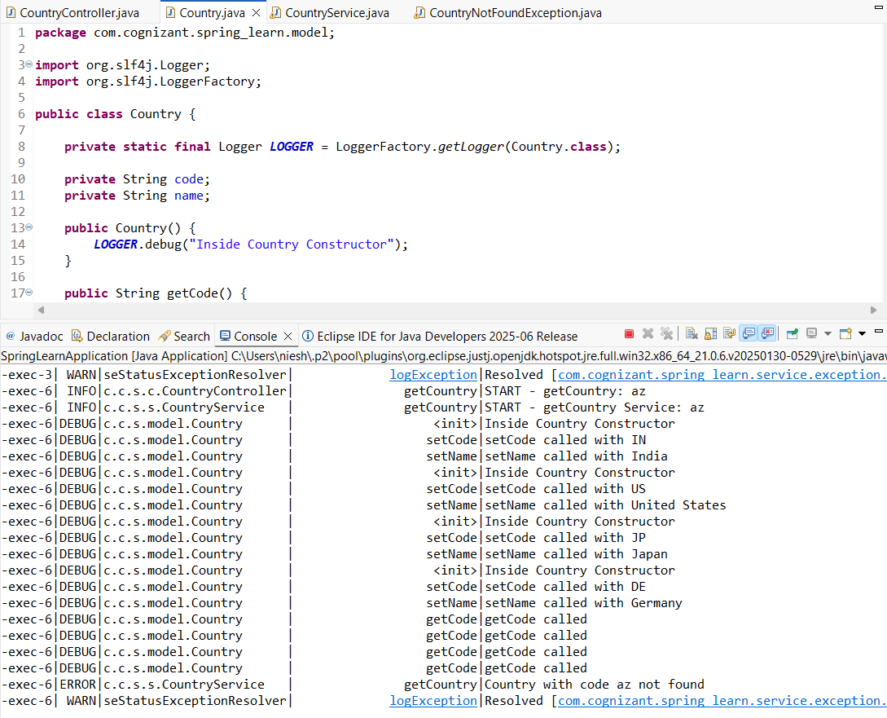

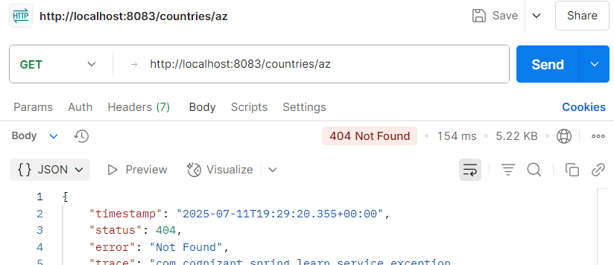

---------------------------------------------------------------------------------------------------------------------------

**MockMVC - Test get country service**   
**1.SpringLearnApplicationTests.java**

package com.cognizant.spring_learn;

import com.cognizant.spring_learn.controller.CountryController;

import org.junit.jupiter.api.Test;

import static org.junit.jupiter.api.Assertions.assertNotNull;

import org.springframework.beans.factory.annotation.Autowired;

import org.springframework.boot.test.context.SpringBootTest;

import org.springframework.test.web.servlet.MockMvc;

import org.springframework.boot.test.autoconfigure.web.servlet.AutoConfigureMockMvc;

import org.springframework.test.web.servlet.ResultActions;

import static org.springframework.test.web.servlet.request.MockMvcRequestBuilders.get;

import static org.springframework.test.web.servlet.result.MockMvcResultMatchers.*;

@SpringBootTest

@AutoConfigureMockMvc

public class SpringLearnApplicationTests {

@Autowired

private CountryController countryController;

@Autowired

private MockMvc mockMvc;

@Test

public void contextLoads() {

assertNotNull(countryController);

}

@Test

public void testGetCountry() throws Exception {

ResultActions actions = mockMvc.perform(get("/country"));

actions.andExpect(status().isOk());

actions.andExpect(jsonPath("$.code").value("IN"));

actions.andExpect(jsonPath("$.name").value("India"));

} }



